To receive transfer orders from Covington or other plants, the receiving location would need to log into the SAM system to receive the inventory.
Material Management/Shipping/Receiving/General Operations/Receive Transfer Order
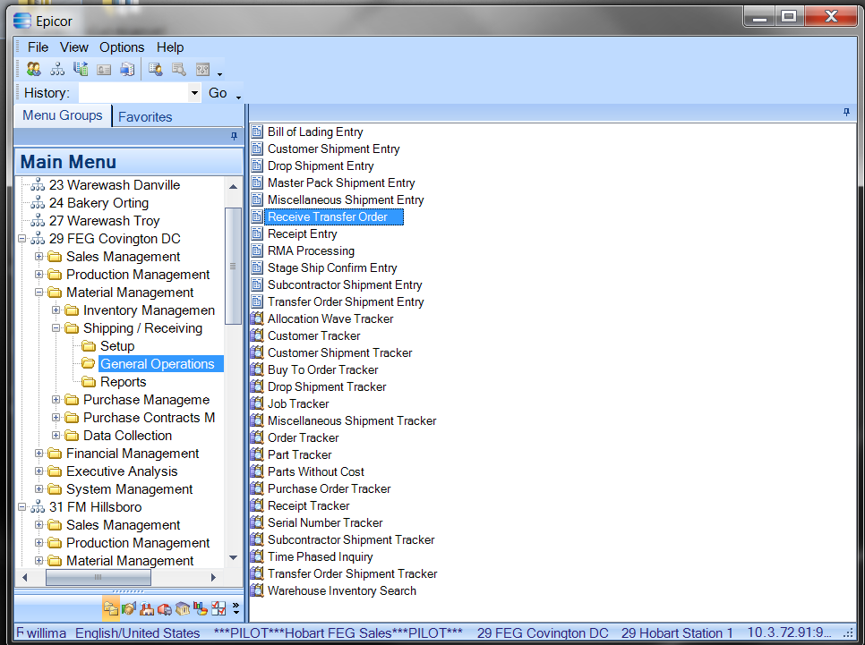

- You must be logged on to the plant you are receiving into (example to 29 Covington).
- Go to Material Management, Inventory Management, General Operations and Double Click on Receive Transfer Order.

Material Management/Shipping/Receiving/General Operations/Transfer Order Receipt
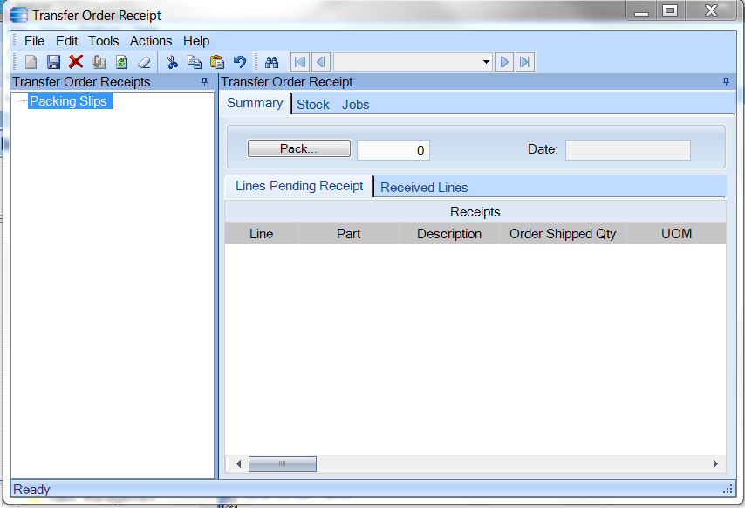

- Transfer Order Receipt screen comes up

Material Management/Shipping/Receiving/General Operations/Transfer Order Receipt
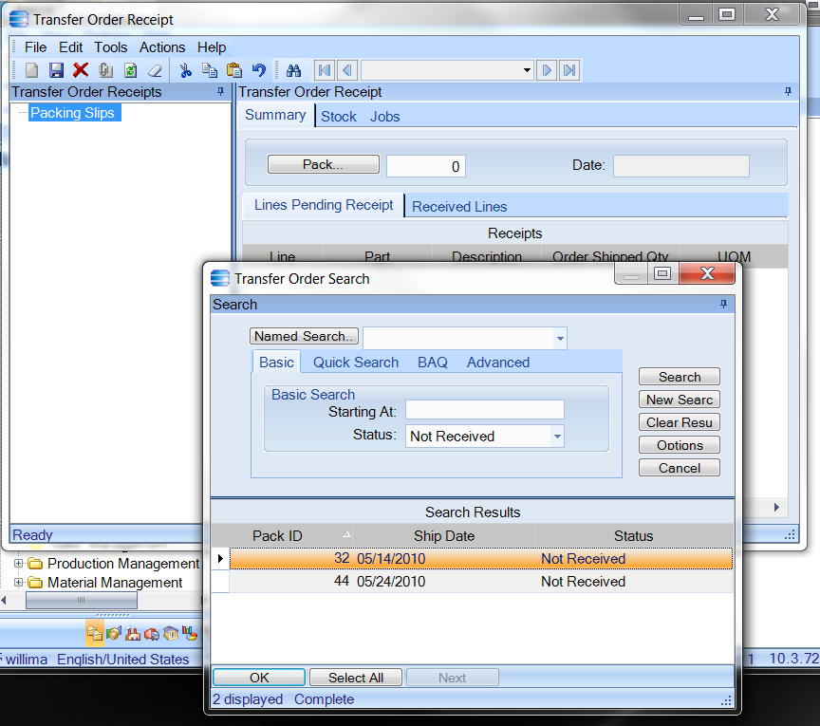
- Can Key in Pack ID number - or –
- Can search using Transfer Order Search drop down

Material Management/Shipping/Receiving/General Operations/Transfer Order Receipt
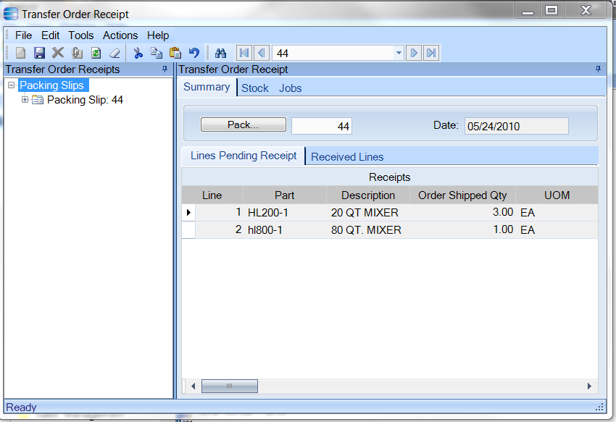

- Lines Pending Receipt are displayed
- Receiver is to process one line at a time
- Transfer orders must be received in their entirety and any discrepancies reported to the origin plant or distribution center

Material Management/Shipping/Receiving/General Operations/Transfer Order Receipt
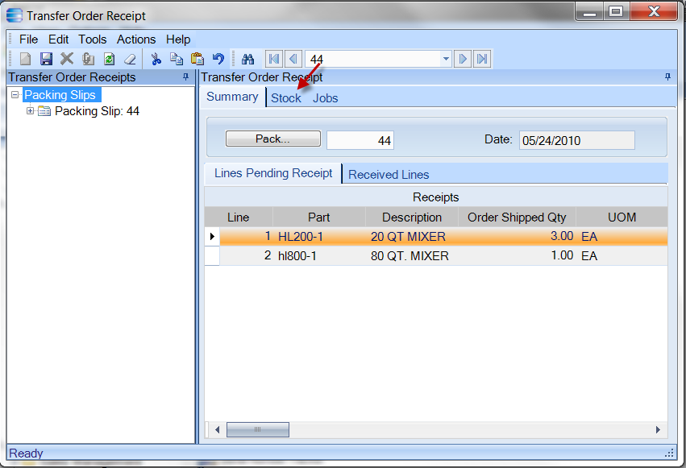
- Choose a line to process
- Click on Stock tab

Material Management/Shipping/Receiving/General Operations/Transfer Order Receipt
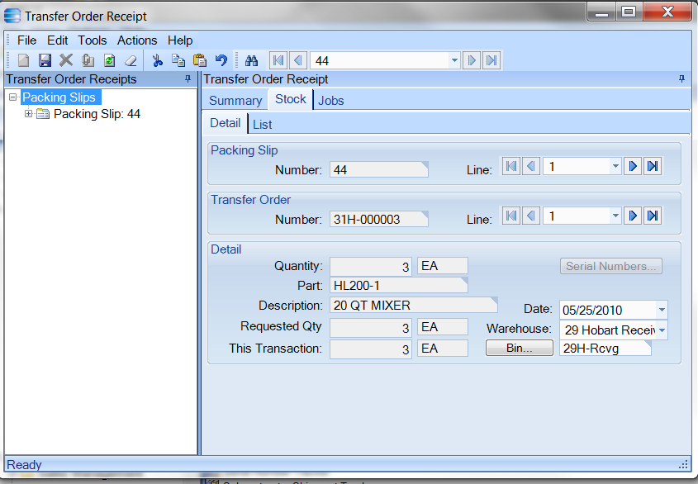
- Stock Detail Screen will appear

Material Management/Shipping/Receiving/General Operations/Transfer Order Receipt
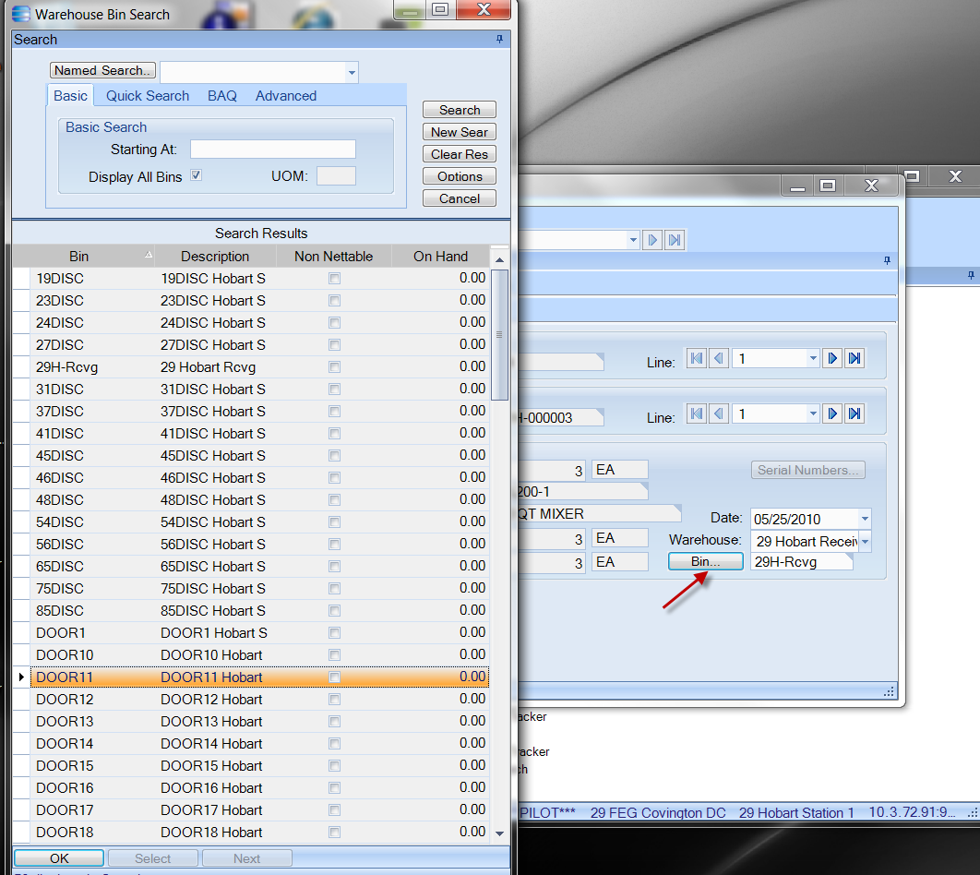
- Either scan in receiving bin – or - type in – or -
- Choose from drop down search listing.
- Click OK
- The Receiving warehouse will default to the receiving warehouse for your plant, can change if needed.

Material Management/Shipping/Receiving/General Operations/Transfer Order Receipt
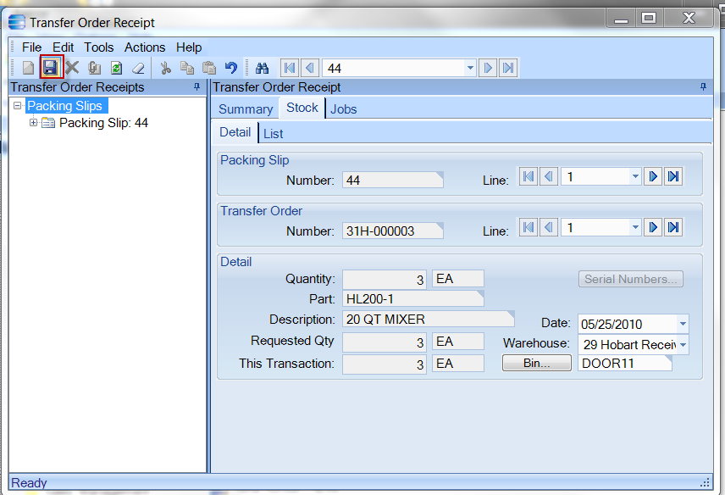
- Click Save.
- Stock Detail Screen clears

Material Management/Shipping/Receiving/General Operations/Transfer Order Receipt
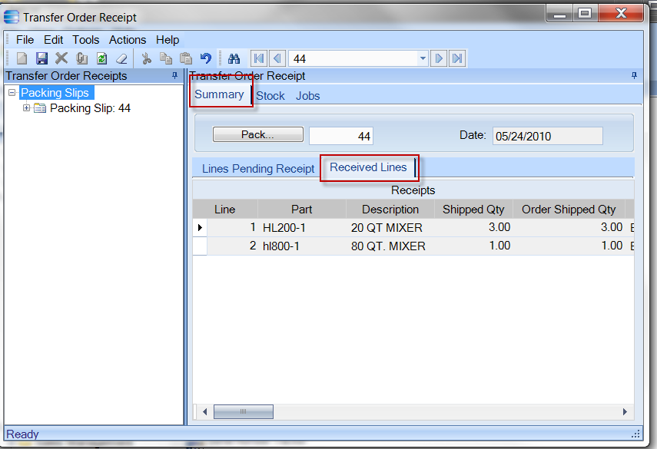
- Click on Summary tab
- Click on Received Lines tab
- Parts received will be listed.
- Click Save button

